DAT601 Project – Coast & Canopy
Dylan Brodie
Contents
Milestone One
Section 1: Introduction to Data Modelling 3
Conceptual Design 3
Logical Design 3
Physical Design 4
Section 2: Description of Conceptual Modelling 5
Chen Notation 5
Depiction 6
Section 3: Conceptual ER Model 9
Entity Relationship Diagram 9
Rationale 9
Section 4: Data Dictionary 11
Table 1: Document Entities 11
Table 2: Document Relationships/Specializations-Generalizations 13
Table 3: Document Attributes 15
Rationale 23
Section 5: Business Rules 24

Milestone Two
Section 1: Transformation from Conceptual to Logical 24
Introduction 24
Mapping Rules Strategy 24
Rationale 24
Section 2: The Logical Database Model 24
Presentation 25
Explanation of Relations 25
Section 3: Normalisation 25
Definitions 25
The Process 25
First Normal Form 25
Second Normal Form 25
Third Normal Form 25
Advanced Normalisation 25
Boyce-Codd Normal Form 25
Fourth Normal Form 25
Section 4: Logical Data Dictionary 26
Section 5: NaLER Analysis 26
Method 26
Analysis 26
Conclusion 26
References 26

DAT601 Assessment 1 Part 2

Milestone 1

Section 1: Introduction to Data Modelling
In all modern organisations, information systems and the data they manage are a critical asset. Industries depend on the information and knowledge within the data. As information has grown in importance, so too have the requirements of the systems managing it. To effectively manage this growing complexity, Data Modelling is used to visualise and plan the data and system architecture.
Modern information systems are built as software, with databases as the underlying framework (Connolly & Begg, 2005, p. 4) and so the process of developing these database systems is known as the Database System Development Lifecycle (DSDLC) (Connolly & Begg, 2005, p. 282). Data modelling is specifically the part of this lifecycle involved in designing the database, and this design is done in three phases: conceptual, logical, and physical (Connolly & Begg, 2005, p. 291).

Conceptual Design
The first phase, the conceptual design, is a model used to define the system independent of all physical considerations such as software or hardware. It is based solely on the user requirements and validated against their use case(s) (Connolly & Begg, 2005, p. 293). These models consist of high-level diagrams, often using Chen notation to define all entities, their attributes, and the basic relationships between entities.

Logical Design
The second phase, the logical design, starts by mapping the conceptual design into a new logical data model, refined to fit into our choice of database solution i.e. relational, object oriented, etc. while still ignorant of physical aspects such as storage structures or specific languages (Connolly & Begg, 2005, p. 294). These designs show the logical view of how each entity and its attributes are connected with relationships such as one to one, one to many, or many to many through primary, or foreign keys. As well as refining how the data is structured using normalisation.

Physical Design
The final phase of data modelling is the physical design. It represents the final blueprint for implementing the database system. It takes into account all physical considerations, including the target DBMS, access methods, and security. It uses the logical design as a source of truth, to define what the physical model needs to implement.

Section 2: Description of Conceptual Modelling

Chen Notation
In 1967 Peter Chen developed the Entity-Relationship Model (Athuraliya, 2025).It is a conceptual model that looks at data from a high level, without any care for physical implementation. It has three main components:
- Entities - The real-world item or concept we are modelling such as a person, or a job. Represented by a rectangular box, with the name of the entity within. Entities can have types, to represent an instance of a specific type or to show inheritance. If an entity relies on a relationship such as an instance relying on a base entity, it is a ‘weak’ entity and is represented with an extra outline.
- Attributes - The properties that describe the entities such as a person’s height, or a job’s salary. Represented as ovals, with the name of the attribute within, connected to the entity by a line. Attributes can be multi-valued, representing a collection of many data points, or derived, to represent data not stored, but instead calculated from other data points. Attributes are also able to be nested in a hierarchy, with complex data such as addresses being split into their constituent parts.
- Relationships - the connections between entities which represent how entities relate, such as a person who ‘has’ a job. This is represented by a diamond between the two entities, with relation written within, and lines connecting each to it. Relationships can have cardinality, such as one to one, one to many, many to one, or many to many, describing the number of instances that can or must be associated with the connected entity.

Depiction
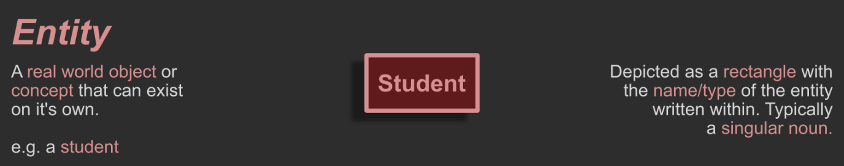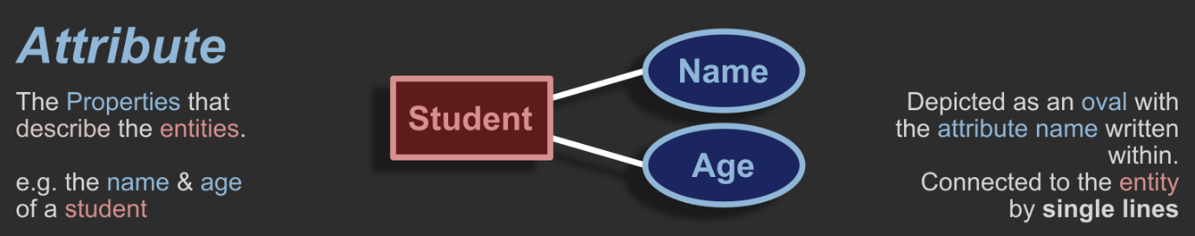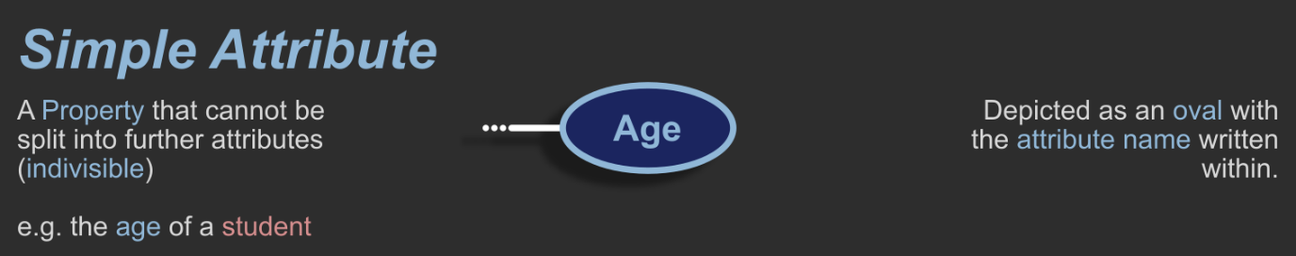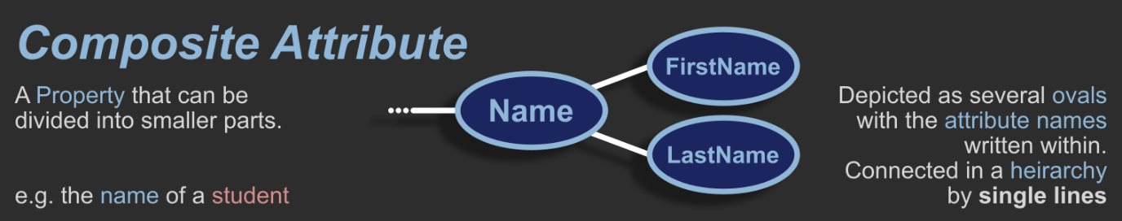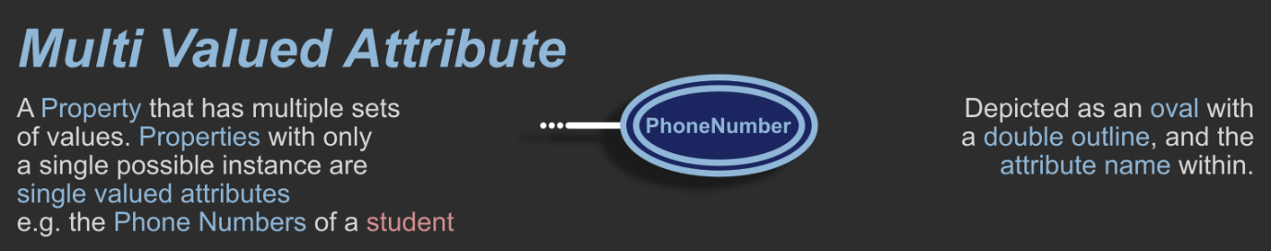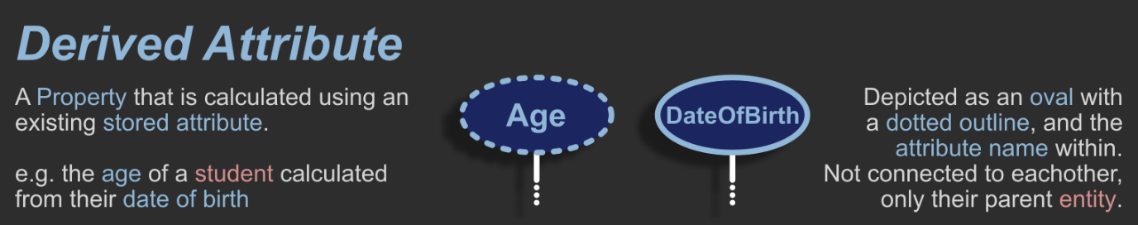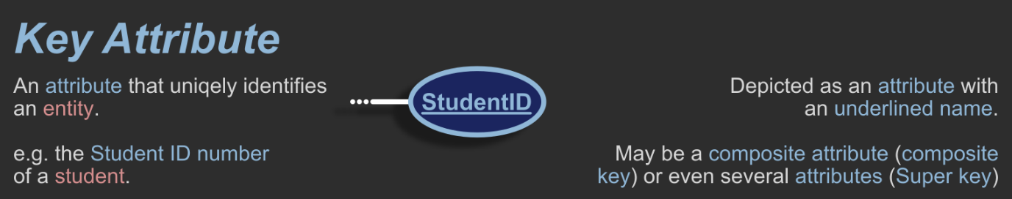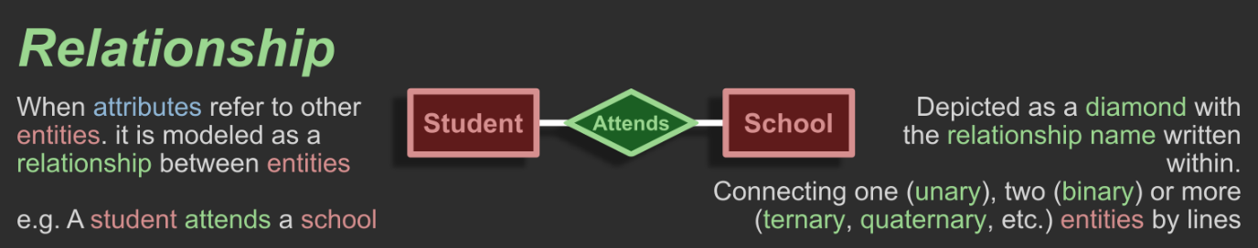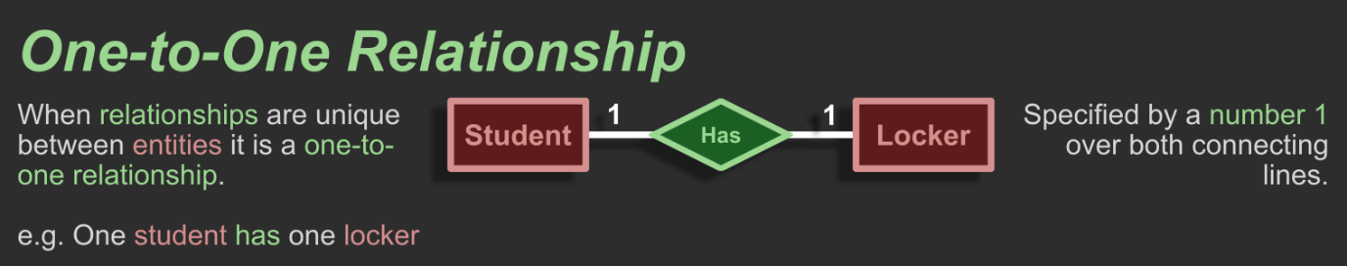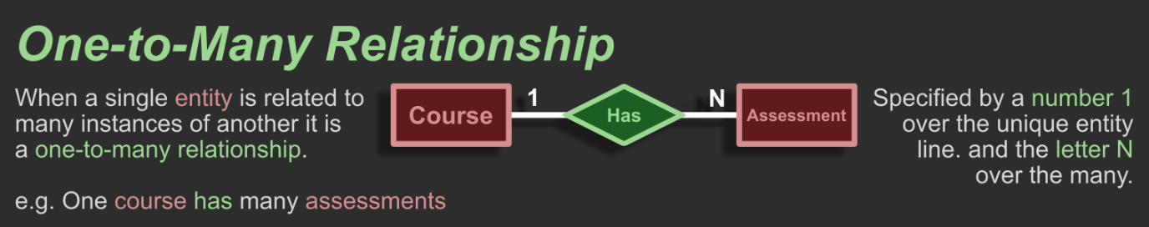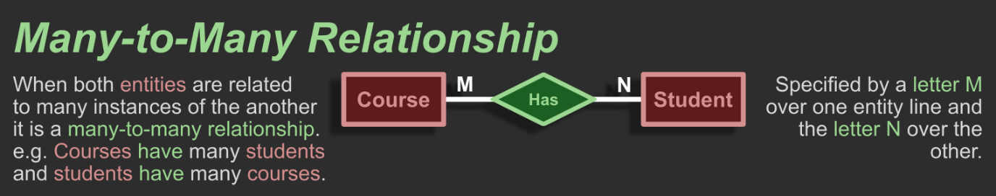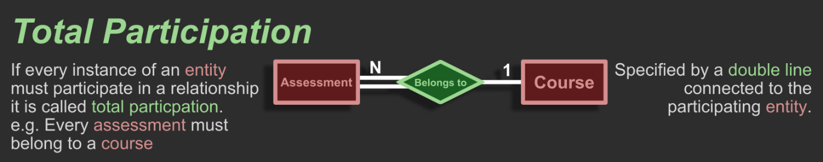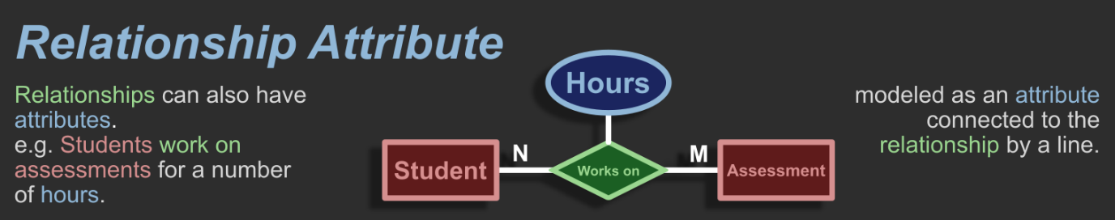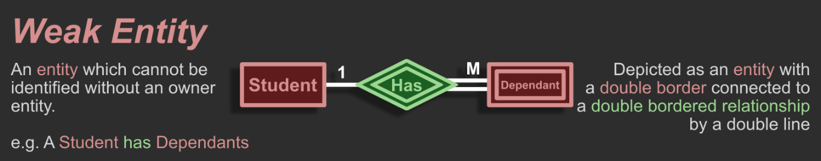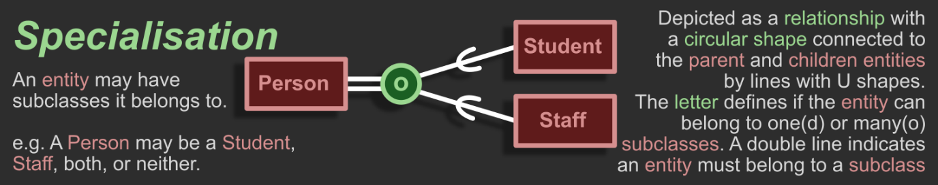

Section 3: Conceptual ER Model

Entity Relationship Diagram
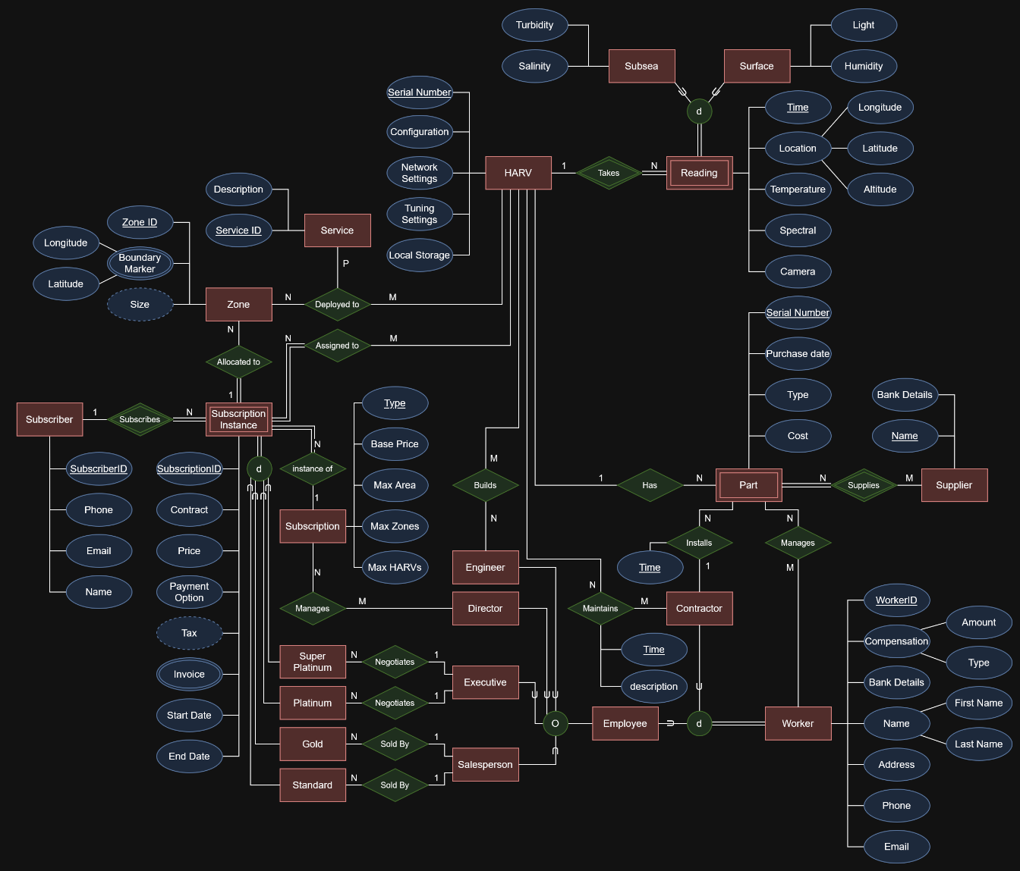

Rationale
While most of the design decisions come directly from the project brief, I made several decisions about how the data would be structured. My primary motivation for these decisions was the less obvious realities of a physical business, such as the supply chain and broad managerial oversight needed for day-to-day business processes.
The management of parts was required to allow oversight of the components used in the HARVs. As a company that operates thousands of drones across the world, a significant effort must be put toward the supply chain. There must be employees at all levels which contribute to this process, from the local contractors sourcing generic parts locally, to high level management making deals with suppliers, and at least several employees responsible for making sure parts are shipped to the many locations that don’t have local sources. I decided all workers will have basic managerial access to the parts to facilitate these business processes. I decided to make all parts weak entity which rely on a supplier. Ensuring supply chain accountability by requiring all parts have been purchased via the business, with warranties and other important details.
For the HARV, I made a reading Weak Entity which exists as a single data entry containing all sensor data from a specific moment in time. This reading has two specialisations which are defined by the HARV’s environment. In the brief, Depth and altitude were separated between airborne and subsea HARV’s. I have chosen to normalise these attributes into a single altitude attribute within the location composite attribute, which may be either positive or negative to define its vertical distance from sea level either upwards or down. I’ve done this to support amphibious HARVs which may transition from subsea to surface or airborne locomotion. As such, the relationship is a distinct specialisation with total participation, meaning a reading must be either surface or subsea when it is recorded, preventing subsea specific data such as salinity being taken out of the water, and vice versa.

Section 4: Data Dictionary

Table 1: Document Entities
Entity Name | Description | Aliases | Occurrence
HARV | Autonomous robot capable of data sensing, collecting, and transmitting | HARV, Drone | 7500
Reading | A sensor reading from a HARV | Reading, scan, photo, datapoint | 750,000,000
Subsea | A sensor reading from a HARV configured for subsea operation | Submarine | 375,000,000
Surface | A sensor reading from a HARV configured for surface operation | Quadcopter, Hexacopter, Rover | 250,000,000
Part | A component of a HARV | Part, Component | 3,000,000
Supplier | The supplier of each part. | Supplier, Vendor, Source | 100
Service | A specific task or routine assigned to a HARV as part of a subscription. | Task, Job, Routine | 5,000
Zone | A designated area assigned to a subscription where HARVs will operate. | Zone, Area, Region | 30,000
Subscriber | An account made with Coast & Canopy which can be used to purchase subscriptions. | Subscriber, Client, Customer | 3,000
Subscription | A type of subscription detailing the level of access and number of HARVs given. | Subscription | 4
Subscription Instance | An instance of a subscription between a subscriber and Coast & Canopy. | Contract | 5,000
Super Platinum | A specialisation of subscription instances with unlimited access to HARVs and special rules negotiated by exectives | Super Platinum | 10
Platinum | A specialisation of subscription instances unlimited access to HARVs | Platinum | 25
Gold | A specialisation of subscription instances with access to three HARVs in three zones totalling no more than 100 hectares. | Gold | 2000
Standard | A specialisation of subscription instances with access to a single HARV in a single Zone no larger than 10 hectares | Standard | 3000
Worker | A person who works for Coast & Canopy | Worker | 500
Contractor | A specialisation of a worker who is contracted for work. Mostly to maintain the HARVs | Contractor | 300
Employee | A specialisation of a worker who is employed directly by Coast & Canopy | Employee | 200
Engineer | A specialisation of an employee who builds HARVs | Engineer | 50
Director | A specialisation of an employee who manages base contract rates | Director | 25
Executive | A specialisation of an employee who negotiates platinum and super platinum subscriptions. | Executive | 25
Salesperson | A specialisation of an employee who sells standard and gold subscriptions | Salesperson | 100

Table 2: Document Relationships/Specializations-Generalizations
Entity Name | Cardinality | Participation | Relationship | Participation | Cardinality | Entity Name
HARV | 1 | Partial | Takes | Total | N | Reading
Reading | 1 | Total | Distinct Specialisation | Partial | 1 | Subsea
Reading | 1 | Total | Distinct Specialisation | Partial | 1 | Surface
HARV | N | Partial | Deployed to | Partial | M | Service
HARV | N | Partial | Deployed to | Partial | M | Zone
HARV | N | Total | Assigned to | Partial | M | Subscription Instance
HARV | N | Partial | Builds | Partial | M | Engineer
HARV | N | Partial | Maintains | Partial | M | Contractor
HARV | 1 | Partial | Has | Partial | N | Part
HARV | N | Partial | Manages | Partial | M | Admin
Subscription Instance | 1 | Total | Allocated To | Partial | N | Zone
Subscription Instance | N | Total | Subscribes | Partial | 1 | Subscriber
Subscription Instance | N | Total | Instance of | Partial | 1 | Subscription
Subscription Instance | 1 | Total | Distinct Specialisation | Partial | 1 | Super Platinum
Subscription Instance | 1 | Total | Distinct Specialisation | Partial | 1 | Platinum
Subscription Instance | 1 | Total | Distinct Specialisation | Partial | 1 | Gold
Subscription Instance | 1 | Total | Distinct Specialisation | Partial | 1 | Standard
Executive | 1 | Partial | Negotiates | Partial | N | Super Platinum
Executive | 1 | Partial | Negotiates | Partial | N | Platinum
Salesperson | 1 | Partial | Sold by | Partial | N | Gold
Salesperson | 1 | Partial | Sold by | Partial | N | Standard
Director | 1 | Partial | Manages | Partial | M | Subscription
Employee | 1 | Partial | Distinct Specialisation | Partial | 1 | Engineer
Employee | 1 | Partial | Distinct Specialisation | Partial | 1 | Director
Employee | 1 | Partial | Distinct Specialisation | Partial | 1 | Executive
Employee | 1 | Partial | Distinct Specialisation | Partial | 1 | Salesperson
Worker | 1 | Total | Distinct Specialisation | Partial | 1 | Employee
Worker | 1 | Total | Distinct Specialisation | Partial | 1 | Contractor
Part | N | Partial | Manages | Partial | M | Worker
Part | N | Partial | Installs | Partial | 1 | Contractor
Part | N | Total | Supplies | Partial | M | Supplier

Table 3: Document Attributes
Entity Name | Attributes | Description | Domain | Aliases | Composite | Derived | Nulls | Key? | Default Value
HARV | Serial Number | Serial number of the HARV. | BIGINT  (1 to 2⁶³-1) |  |  |  | NO | Primary | Auto Increment
 | Configuration | The specific setup the HARV has been configured for. | ENUM  (‘Quadcopter’, ‘Rover’, etc.) |  |  |  | NO
 | Network Settings | The networking data required to connect. | VARCHAR  (Valid filepath) |  |  |  | NO
 | Tuning Settings | the electric motor tuning settings. | VARCHAR  (Valid filepath) |  |  |  | NO
 | Local Storage | The backup data stored aboard the HARV | BLOB  (Compressed ZIP, Maximum 2GB) | Backup |  |  | YES
Reading | Time | The time the reading was taken | DATETIME  (Second precision, from Jan 1st 1753 to Dec 31st 9999 |  |  |  | NO | Composite Primary | Current Time
 | Location | The specific location where the reading was taken | Composite  (Three decimal values) |  |  |  | NO | Composite Primary
 | Longitude | The longitude value of the location | DECIMAL  (9,6 from -180 to +180) | GPS | Location |  | NO
 | Latitude | The latitude value of the location | DECIMAL  (8,6 from +90 to  -90) | GPS | Location |  | NO
 | Altitude | The altitude value of the location | DECIMAL  (8,2 from +999,999.99 to  -999,999.99) |  | Location |  | NO
 | Temperature | The ambient temperature when the reading was taken | DECIMAL  (5,2 from +999.99 to -999.99) |  |  |  | YES
 | Spectral | The Spectral data of the reading | BLOB  (Spectral sensor output) |  |  |  | YES
 | Camera | the photo/video data of the reading | BLOB  (camera output file) |  |  |  | YES
Surface | Light | The ambient light when the reading was taken | DECIMAL  (8,2 from 0 to 999,999.99) |  |  |  | YES
 | Humidity | The humidity when the reading was taken | DECIMAL  (5,2 from 0.00 to 100.00) |  |  |  | YES
Subsea | Turbidity | The turbidity of the water when the reading was taken | DECIMAL  (5,2 from 0.00 to 999.99) |  |  |  | YES
 | Salinity | The salinity of the water when the reading was taken | BIGINT  (1 to Max Positive Integer) |  |  |  | YES
Service | Service ID | The unique identifier of the service | BIGINT  (1 to Max Positive Integer) |  |  |  | NO | Primary | Auto Increment
 | Description | The description of the task the HARV must complete | VARCHAR  (Max length: 2048) |  |  |  | NO
Zone | Zone ID | The ID of the zone | BIGINT  (1 to 2⁶³-1) |  |  |  | NO | Primary | Auto Increment
 | Boundary Marker | The collection of markers defining the area of the zone | Multivalued collection of GPS Coordinates (Longitude + Latitude) |  |  |  | NO
 | Longitude | the longitude of a specific boundary marker | DECIMAL  (9,6 from -180 to +180) | GPS | Boundary Marker |  | NO
 | Latitude | the latitude of a specific boundary marker | DECIMAL  (8,6 from +90 to  -90) | GPS | Boundary Marker |  | NO
 | Size | The derived square area of the zone | DECIMAL  (10,4 from 0 to 999,999.9999) |  |  | Boundary Marker | NO
Subscriber | Subscriber ID | The ID of the subscriber | BIGINT  (1 to 2⁶³-1) |  |  |  | NO | Primary | Auto Increment
 | Phone | The phone number contact of the subscriber | VARCHAR  (max length: 10) |  |  |  | NO
 | Email | The email contact of the subscriber | VARCHAR  (max length: 256) |  |  |  | NO
 | Name | The name of the subscriber | VARCHAR  (max length: 256) |  |  |  | NO
Subscription | Type | the type of subscription such as gold or platinum | ENUM  (‘gold’, ‘platinum’, etc.) |  |  |  | NO | Primary
 | Base Price | The base price of the subscription | DECIMAL  (8,2 from 0.00 to 999,999.99) |  |  |  | NO
 | Max Area | The maximum area allowed by a subscription | DECIMAL  (10,2 from 0 to 99,999,999.99) |  |  |  | NO
 | Max Zones | The maximum zones allowed by a subscription | INT  (1 to 2³¹-1) |  |  |  | NO
 | Max Harvs | The maximum HARVs allowed by a subscription | INT  (1 to 2³¹-1) |  |  |  | NO
Subscription Instance | Subscription ID | The ID of the subscription | BIGINT  (1 to 2⁶³-1) |  |  |  | NO | Primary | Auto Increment
 | Contract | The scanned contract document | BLOB  (Valid PDF) |  |  |  | NO
 | Price | The final price of the subscription | DECIMAL  (8,2 from 0.00 to 999,999.99) |  |  |  | NO
 | Payment Option | Whether the payment is monthly or yearly | BOOLEAN  (True or false) |  |  |  | NO
 | Tax | The calculated tax amounts | DECIMAL  (8,2 from 0.00 to 999,999.99) |  |  | Price | NO
 | Invoice | The collection of invoices kept for the subscription | Multi valued BLOB  (instances of valid PDF documents) |  |  |  | NO
 | Start Date | the start date of the subscription | DATETIME  (millisecond precision, from Jan 1st 1753 to Dec 31st 9999) |  |  |  | NO
 | End Date | the end date of the subscription. Nullable for ongoing subscriptions. | DATETIME  (millisecond precision, from Jan 1st 1753 to Dec 31st 9999) |  |  |  | YES
Part | Serial Number | The serial number of the part | BIGINT  (1 to 2⁶³-1) |  |  |  | NO | Primary | Auto Increment
 | Purchase Date | The date the part was purchased | DATE  (0000-00-00 to 9999-12-31) |  |  |  | NO
 | Type | The type of part | VARCHAR  (Max length: 256) |  |  |  | NO
 | Cost | The amount paid for each specific part | DECIMAL  (10,2 from 0.00 to 99,999,999.99) |  |  |  | NO
Supplier | Name | The name of the supplier | VARCHAR  (Max length: 256) |  |  |  | NO | Primary
 | Bank Details | The payment info for the supplier | VARCHAR  (Max length: 32) | Bank Account |  |  | NO
Worker | Worker ID | The unique ID of the worker | INT  (1 to 2³¹-1) |  |  |  | NO | Primary | Auto Increment
 | Compensation | The money given to the worker as compensation for their labour | Composite data of an amount and type. | Wage, Salary |  |  | NO
 | Amount | The amount of money to be paid | DECIMAL  (10,2 from 0.00 to 99,999,999.99) |  | Compensation |  | NO
 | Type | The way the compensation is paid e.g. salary, contract, wage, | ENUM  (‘salary’, ‘wage’, ‘contract’) |  | Compensation |  | NO
 | Bank Details | The bank details of the worker | VARCHAR  (Max length: 32) |  |  |  | NO
 | Name | The full name of the worker | Composite data of first, middle, and last names. |  |  |  | NO
 | First Name | The first name of the worker | VARCHAR  (Max length: 256) |  | Name |  | NO
 | Last Name | The last name of the worker | VARCHAR  (Max length: 256) |  | Name |  | NO
 | Address | the physical address of the worker | VARCHAR  (Max length: 512) |  |  |  | NO
 | Phone | The phone numbers associated with the worker | VARCHAR  (Max length: 32) |  |  |  | NO
 | Email | The email addresses associated with the worker | VARCHAR  (Max length: 256) |  |  |  | NO

Rationale
When organising all required data into rigid tables ready for implementation, I made several key decisions, primarily concerning the domain of each attribute. Establishing the scope of each attribute is a tug of war between the limits of what should be possible, and what is possible. So I checked documentation and other sources listed below to understand the limits of each datatype available. From those limits, I decided which type to use, to suit the data’s requirements.
A common decision I made was between INT and BIGINT. The difference is a limit of roughly two billion for INT, and nine quintillion for BIGINT. This was mostly for IDs and an example is how employee ID is an INT, while a part serial number is a BIGINT. I thought hiring a large portion of the world’s population was plenty optimistic, but parts are essentially consumables, and if this system reaches many years of age, historic data will require a significant limit.
The HARV’s readings presented many challenges in defining the domain. Longitude and latitude require different limits both positive and negative, and many decimal places for accuracy since they are degrees on a sphere. Altitude was again unique, measuring metres above or below sea level. Sensor readings such as Spectral data and turbidity readings had to be sourced from products online (Micasense RedEdge-P, n.d.) (“Turbidity Sensor,” n.d.) (“Salinity Sensor,” n.d.) and many of the onboard data for the HARV such as tuning settings and local storage needed unique or complex datatypes to handle data such as BLOBs for files like the images captured by cameras.

Section 5: Business Rules
The brief includes many requirements and rules for the data model and its processes. These rules have shaped the decisions I’ve made as I’ve planned and designed the data model, and I’ve made reference to them in much of my previous rationales concerning the data dictionary and ERD. These rules can be broadly organised into several categories, covering the various aspects of the system being built, its users, and the processes it performs. These categories are:
- Subscriptions
- HARV Operations
- Maintenance
- Organisational
- Technical
The Subscriptions have many rules concerning the types of subscription they are, the differences between them, as well as how their contracts are negotiated. For example, the business requires four types of subscription: Standard, Gold, Platinum, and Super Platinum. Each has their own limits regarding how many HARVs may be deployed, how many zones they may be deployed to, and the maximum sizes of those zones. The platinum and super platinum are specifically required to be negotiated by a specific role in the organisation: the executive administrator. Another privilege of the super platinum subscription is the exclusive use of specific HARVs, whereas all other subscriptions may share the same HARVs. Payment for these subscriptions may be paid either monthly or annually, with annual plans receiving a 10% discount so long as they are a standard or gold subscription. Salespeople may also optionally apply a 3% discount.
The HARVs rules mostly cover the data being recorded and how it’s managed, but also how they are deployed and configured. A major rule being that data is recorded every second, which informed my decision on how precise the time attribute of the readings should be. Every recorded reading requires longitude, latitude, and altitude/depth to place the recording. As the zones the HARVs are deployed must be able to be placed globally, the data must support that. While HARVs are required to be connected to networks such as mobile and/or satellite for transmitting data, it is expected that they will not be connected at all times, and so an onboard cache of data coving the last month of data must be held for backup and retention.
To keep these HARVs operational, maintenance is an important requirement. Due to the global nature of the business, 3rd party contractors are required to perform this maintenance. All maintenance done on the HARVs requires a historic record and is informed by a maintenance schedule, with a default interval of five years. The parts used in the HARVs also require a robust tracking system which records the supplier, price, and age of each individual part.
Coast and Canopy as an organisation has several rules which define the hierarchy and responsibilities of the staff members. Directors are the only employees able to adjust base fees of subscriptions. Executive administrators are the only employees able to negotiate platinum and super platinum subscriptions. All HARVs must be linked to the specific engineer who built them. And as mentioned before, 3rd party contractors perform all maintenance and field service.
While mostly implicit requirements of the system being built, there are many specific requirements put forth in the brief covering the technical processes of the system and how it should operate. These include how invoices are generated, with clearly separated GST and prices as well as what processes are required. The brief includes a list of the many transactional procedures needed, including tracking HARV maintenance, deleting data from historic contracts, and finding all suppliers parts have been sourced from for specific HARVs. Streaming data from the HARV to the database via network is also a critical requirement.

DAT601 Assessment 2 Part 1

Milestone 2

Section 1: Transformation from Conceptual to Logical

Introduction
In the previous milestone, I created a conceptual model for the data held by Coast & Canopy, a drone company, who provides service world-wide, gathering readings from unmanned aerial, subsea, and roving platforms. In this second milestone, I’ll transform the conceptual model into a logical model, ready for implementation in a database software. As the name suggests, a conceptual model is only the preliminary concept of the design, establishing what the system should contain from a high-level perspective. It has many nuances such as casual naming conventions, which will not work in a strict database schema. By transforming this concept into a logical diagram, we map it to the strictly defined logic of our database.

Mapping Rules Strategy
To map the conceptual diagram to a logical one, mapping rules are used to define the transformation process. They are as follows:
- Every Entity becomes a table with (key) attributes as columns
  - All of the entities both strong and weak map directly to tables within a database. Using attributes as columns, with primary keys.
- Weak entities use composite primary keys connected to the foreign key of a strong entity.
  - Weak entities explicitly rely on a strong entity to distinguish themselves, and this data is held as one half of the composite primary key, the other half being the unique id of the weak entity itself.
- Composite attributes are flattened as separated columns of the table
  - Combining attributes is typically done for legibility or simplifying queries, and thus is done through code, not stored in the database, as that would be duplicating data.
- Multi-Valued attributes are mapped as new weak entities, and thus, tables connected to their parent entity.
  - In order to store a collection of data of indeterminant length, a new table is needed.
- Derived attributes are not mapped into the logical diagram tables.
  - Derived or calculated fields are done via queries, not as fields in a table, as it could introduce duplication.
- One to one relationships are mapped as foreign keys in one table with a UNIQUE constraint
  - Either table can host the foreign key, but in order to enforce the one-to-one relationship, every row must have a unique foreign key.
- One to many relationships are mapped as foreign keys held in the many table.
  - The one table has it’s primary key referenced as a foreign key in the many table entries.
- Many to many relationships are mapped to joining tables with composite foreign primary keys of all connected entities.
  - In order to store an indeterminate number of connections between many entities in both cardinalities, a joining table is required.
- Ternary or larger relationships are mapped as a joining table.
  - Relationships between more than two entities require composite primary foreign keys to connect all entities together.
- Optional participation is represented though nullable foreign keys
  - If the relationship is optional then the foreign key column must be able to be left blank.
- Relationships with attributes are mapped as columns in a joining table
  - To store the data of a relationship such as a maintenance record, a joining table connecting the two entities requires columns for each attribute of the relationship.
- Specialisation is mapped as single tables for the entire hierarchy.
  - Specialisation has many possible mappings, for this system, a flat hierarchy handled by attribute flags is my chosen solution.
- Access privilege relationships are not mapped to the logical model
  - Access privileges are handled separately from the data model and thus are not represented in the logical model.

Section 2: The Logical Database Model

Logical ERD
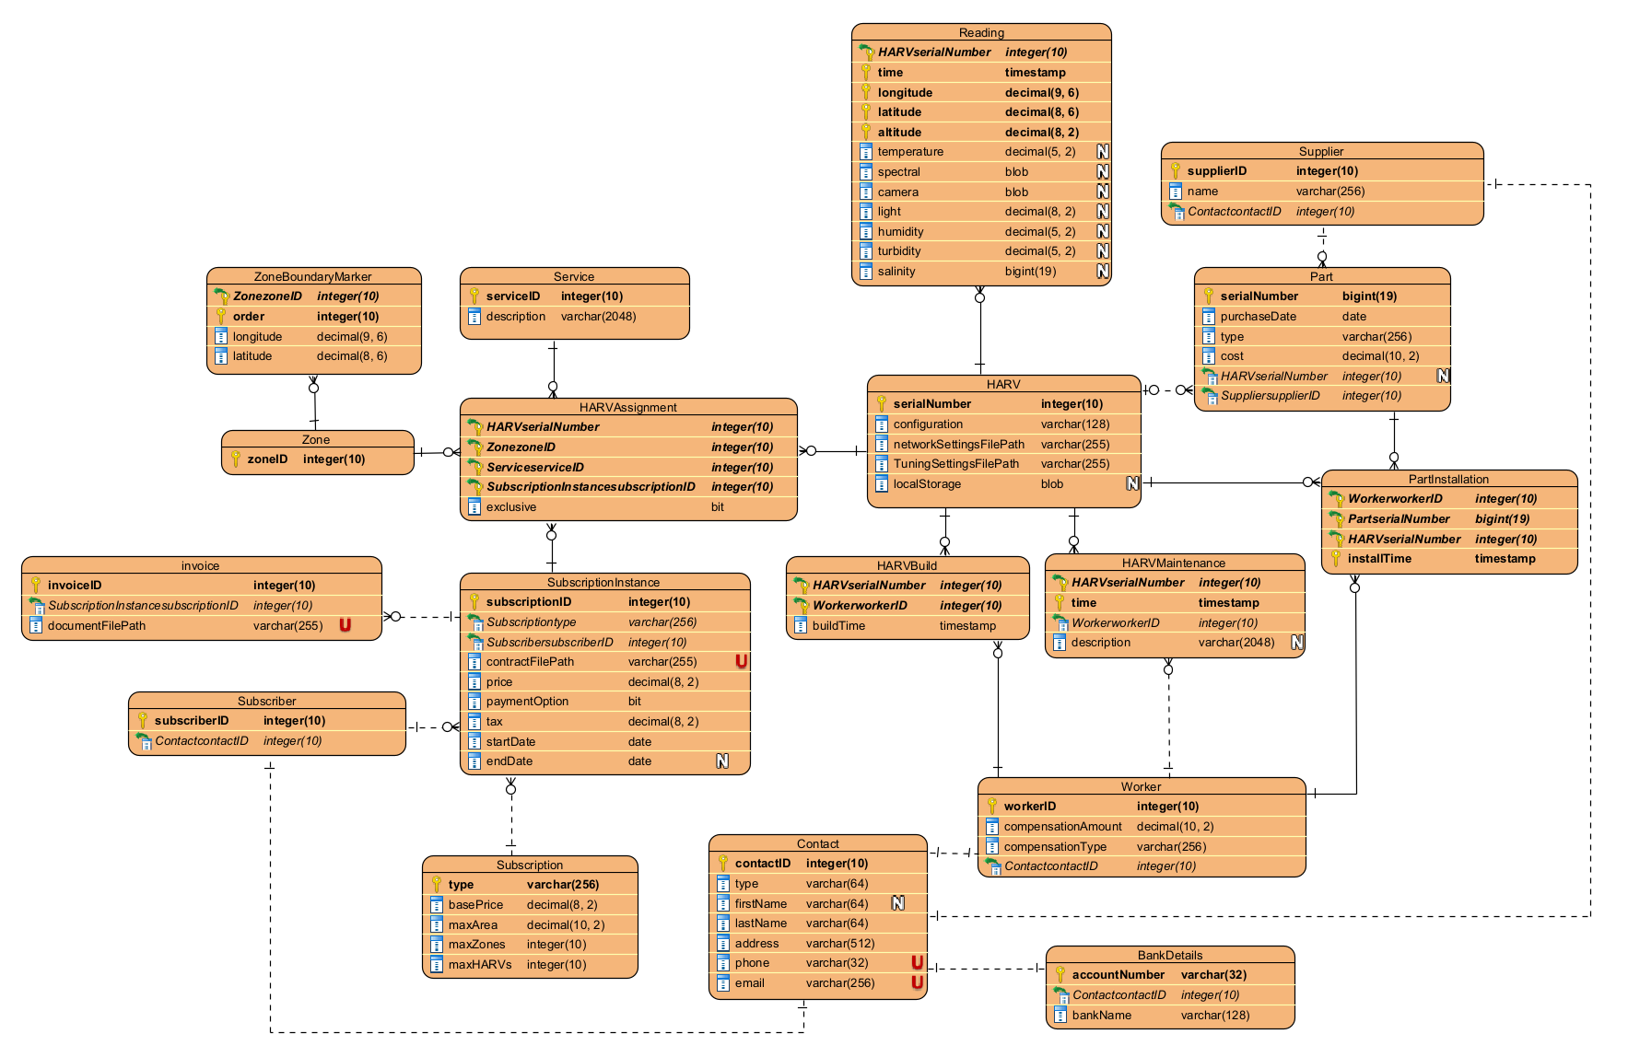

Explanation of Relations
The key tables of this database are the HARV and SubscriptionInstance tables, which sit centrally among the various associated tables. At the core of business operations is the intersection of these two tables, the HARVAssignment table. This table defines the operations of HARVs within specific zones, performing specific services, for Subscription Instances. All other tables serve to facilitate this core business process.
Zones and Services are less central, but nonetheless critical tables holding data for the geographic locations of services to be undertaken by the HARVs. Zones are defined by boundary markers holding gps coordinates, which are stitched into a polygon by following the order.
The subscription instance is the centre of customer processes, holding an instance of the subscription a user has acquired. While it follows a template from the Subscription table, the higher tiers of subscriptions are able to be negotiated.
HARVs are autonomous and piloted drones for use in airborne, surface, or subsea operations. They collect readings as defined in the Reading table, and are assigned via the HARVAssignment table, but also have connections to operational and historic data. These connections include the construction of the HARV in the HARVBuild table, maintenance records in the HARVMaintenance table, current data of installed and stored parts, tracked by the Part table, and historic data of part installations in the PartInstallation. The part table includes a required link to the supplier of the part, held in a supplier table. This means that Parts are weak entities relying on their supplier. This is done for supply chain business rules.
To support all these processes and hold user information, a contact table is used as the source of contact information for the Customer, Worker, and Supplier tables. It uses a BankDetails table to hold financial information as all contacts interact financially with the business either giving or receiving money. Workers have many connections with the operational data in the HARVBuild, HARVMaintenance, and PartInstallation tables.

Section 3: Normalisation

Definitions
Normalisation is the “process of organizing the attributes of the database to reduce or eliminate data redundancy” (Introduction to Database Normalization, n.d.). each normal form focuses on a specific kind of data transformation, and to normalise a database, you typically go through them one by one, validating each’s rules and altering your database to meet these requirements. Each normal form requires the previous to be true before moving on to the next, so it is structured as a sequence.

First Normal Form
First normal form (1NF) enforces atomicity by requiring all attributes contain single, indivisible values and that repeating groups are eliminated. Atomicity is a foundational principle and critical for efficient storing of data. It’s important to keep this principle in mind when initially designing the database, as it implies much of the foundational architecture.
The mapping of the logical diagram from the conceptual diagram involved flattening composite attributes into atomic columns, each representing one piece of the previously composite data.

Second Normal Form
Second normal form (2NF) ensures the database contains no partial-dependencies, meaning that each non-prime attribute must depend on the entire set of primary keys, not just a subset. If data is irrelevant to a subset of keys, then it should be placed in the relevant table.
In the logical diagram, customers and workers do not have their own copy of their contact details, it’s instead held in the contact table, and connected the foreign key as the identifier.

Third Normal Form
Third normal form (3NF) requires no transitive dependencies, meaning that non-prime attributes must relate to the identifier or primary key(s), not other non-prime attributes. If an attribute depends on a non-prime attribute, it means they may belong in another table relevant to those attributes, and referenced with a foreign key.
By mapping the contact information of the previously disconnected customer, worker, and supplier entities to a new Contact table, transitive dependencies are lost, and data will not be duplicated when a customer is also a worker or supplier.

Boyce-Codd Normal Form
Boyce-Codd normal form (BCNF or 3.5NF) takes third normal form further by requiring that every determinant in a functional dependency is a candidate key. This means no attribute or group of attributes can determine another attribute without uniquely identifying the record.
It enforces many of the edge cases of 3NF, for example, The PartInstallation table must include the installTime as a candidate key, otherwise it would imply a part may only be installed in the same HARV by the same worker once. By making the time also identify each record, the unique identities gain a dimension and enforce an architecture consistent with business rules.

Fourth Normal Form
Fourth normal form (4NF) handles multi-valued dependencies by ensuring that a table does not contain multiple independent many-to-many relationships. A table is in 4NF when all multi-valued dependencies depend only on a candidate key and are separated into their own related tables. This prevents redundant combinations of unrelated data and reduces update anomalies caused by storing independent sets of values together.
In the logical model, HARV assignments, part installations, and maintenance records are separated into independent tables. Each table represents a distinct relationship or event, preventing unrelated repeating sets of data from being combined into a single table.

Section 4: Logical Data Dictionary

Document Relation
Relation Name | Start Volume | Growth | Comments
Reading | 4,000,000 | +10M per year / HARV | 1 reading per second is 28,800 in 8 hours, which is just over 10 million in a year, assuming 8 hours a day average.
HARV | 100 | +10% per year | HARVs may need replacing and the business may expand. Historic data will always be kept.
HARVBuild | 100 | +20% per year
HARVMaintenance | 100 | +12 per year / HARV
HARVAssignment | 100 | +300 per year
Service | 20 | +5 per year | standardised services across all clients. Only growth is special clients.
Zone | 200 | +200 per year | polygon defining area of service by HARVs. Assumed to have many new zones with each new subscription
ZoneBoundaryMarker | 1200 | +1200 per year | Assuming the average area is defined by 6 points.
SubscriptionInstance | 30 | +100 per year
Subscription | 4 | 0 | templates for subscriptions are defined by business rules and have no growth.
Subscriber | 25 | +80 per year | I’m optimistic.
Invoice | 100 | +12 per year / SubscriptionInstance
Contact | 500 | +200 per year | every contact of every worker, customer and supplier.
BankDetails | 500 | +200 per year | One-to-one relationship with Contact.
Worker | 100 | +30% per year | Accounting for turnover, global contractors, and company growth.
PartInstallation | 300 | +3 per year / HARV | average of three replaced parts a year per HARV
Part | 10,000 | +2500 per year | each HARV should have roughly 100 parts. Historic data is preserved.
Supplier | 50 | +30 per year | Many parts are generic and can have new suppliers.

Document Attributes
Relation Name | Attribute | Description | Data type | Length | Validation Rules | Default Value | Nulls | Key? | References Entity | Integrity Constraints
Reading | HARV.serialNumber | Unique serial of the HARV | INTEGER |  | Unique, Auto-increment |  | No | PK | HARV | PK, FK
 | time | Exact second of data capture | TIMESTAMP |  |  |  | No | PK
 | longitude | GPS Longitude coordinate | DECIMAL | 9,6 |  |  | No | PK
 | latitude | GPS Latitude coordinate | DECIMAL | 8,6 |  |  | No | PK
 | altitude | Height above/below sea level (meters) | DECIMAL | 8,2 |  |  | No | PK
 | temperature | Ambient temperature reading | DECIMAL | 5,2 |  |  | Yes
 | spectral | Raw spectral sensor data | BLOB |  |  |  | Yes
 | camera | Image or video frame capture | BLOB |  |  |  | Yes
 | light | Light intensity level(lumens) | DECIMAL | 8,2 |  |  | Yes
 | humidity | Humidity percentage | DECIMAL | 5,2 |  |  | Yes
 | turbidity | Water movement measurement | DECIMAL | 5,2 |  |  | Yes
 | salinity | Salt concentration (if subsea) | BIGINT |  |  |  | Yes
HARV | serialNumber | Unique serial number of the HARV | INTEGER |  | Unique, Auto-increment |  | No | PK |  | PK
 | configuration | configuration of the HARV’s hardware/software | VARCHAR | 128 |  |  | No
 | networkSettingsFilePath | File path to network settings file | VARCHAR | 255 |  |  | No
 | tuningSettingsFilePath | File path to electric motor tuning settings file | VARCHAR | 255 |  |  | No
 | localStorage | Blob of compressed archive data (1 month) | BLOB |  |  |  | No
Service | serviceID | Unique identifier of each service offered | INTEGER |  | Unique, Auto-Increment |  | No | PK |  | PK
 | description | Text description of the work and actions involved in the service. | VARCHAR | 2048 |  |  | No
Zone | zoneID | Unique Identifier of a specific zone worked in by HARVs | INTEGER |  | Unique, Auto-Increment |  | No | PK |  | PK
ZoneBoundaryMarker | Zone.zoneID | Zone the boundary marker defines | INTEGER |  | Foreign key |  | No | PK, FK | Zone | PK, FK
 | order | order in which the boundary markers draw the polygon of the zone | INTEGER |  |  |  | No | PK |  | PK
 | longitude | GPS Longitude coordinate | DECIMAL | 9,6 | between -180 and +180 |  | No
 | latitude | GPS latitude coordinate | DECIMAL | 8,6 | between -90 and +90 |  | No
HARVAssignment | HARV.serialNumber | Unique serial number of the HARV assigned | INTEGER |  |  |  | No | PK, FK |  | PK, FK
 | Zone.zoneID | Unique identifier of the zone in which the assigned HARV will operate | INTEGER |  |  |  | No | PK, FK |  | PK, FK
 | Service.serviceID | Unique identifier of the service the HARV will perform in the zone | INTEGER |  |  |  | No | PK, FK |  | PK, FK
 | Subscription.subscriptionID | Unique identifier of the subscription the assignment is done under. | INTEGER |  |  |  | No | PK, FK |  | PK, FK
 | exclusive | Flag determining if a HARV assignment is exclusive to a specific subscription. | BOOLEAN |  |  |  | No
SubscriptionInstance | subscriptionID | unique identifier of the subscription instance | INTEGER |  | Unique, Auto-Increment |  | No | PK |  | PK
 | subscription.type | the base type of subscription | VARCHAR | 255 |  |  | No | FK | subscription | FK
 | subscriber.subscriberID | unique identifier of the user who has purchased this subscription | INTEGER |  |  |  | No | FK | subscriber | FK
 | contractFilePath | File path to the contract document | VARCHAR | 255 | Unique |  | No
 | price | the weekly/monthly price before tax of the subscription instance | DECIMAL | 8,2 |  |  | No
 | paymentOption | flag designating a weekly vs monthly payment | BIT |  |  |  | No
 | tax | the amount of tax paid. | DECIMAL | 8,2 |  |  | No
 | startDate | the first day the subscription will be active | DATE |  |  |  | No
 | endDate | the last day the subscription will be active | DATE |  |  |  | Yes
Subcription | type | The type of subscription i.e. gold, platinum, etc. | VARCHAR | 255 |  |  | No | PK |  | PK
 | basePrice | the default price of the subscription | DECIMAL | 8,2 |  |  | No
 | maxArea | the maximum total area of zones in metres squared. | DECIMAL | 10,2 |  |  | No
 | maxZones | the maximum number of zones assigned to a subscription | INTEGER |  |  |  | No
 | maxHARVs | the maximum number of HARVs that may be assigned to a subscription | INTEGER |  |  |  | No
Subscriber | subscriberID | The unique identifier of the subscribed customer | INTEGER |  | Unique, Auto-Increment |  | No | PK |  | PK
 | contact.contactID | the link to the contact details of the subscriber. | INTEGER |  |  |  | No | FK | contact | FK
Invoice | invoiceID | The unique identifier of each invoice. | INTEGER |  | Unique, Auto-Increment |  | No | PK |  | PK
 | subscriptionInstance.SubscriptionInstanceID | the link to the subscription the invoice is for. | INTEGER |  |  |  | No | FK | subscriptionInstance | FK
 | documentFilePath | the file path to the invoice document file. | VARCHAR | 255 | Unique |  | No
Part | serialNumber | The unique identifier of the part | BIGINT |  | Unique, Auto-Increment |  | No | PK |  | PK
 | purchaseDate | The day the part was purchased. | DATE |  |  |  | No
 | type | the type of part. | VARCHAR | 255 |  |  | No
 | cost | the price paid for the part | DECIMAL | 10,2 |  |  | No
 | HARV.serialNumber | the HARV the part is currently installed in. | INTEGER |  |  |  | Yes | FK | HARV | FK
 | Supplier.supplierID | the supplier of the part | INTEGER |  |  |  | No | FK | Supplier | FK
Supplier | supplierID | the unique identifier of the supplier | INTEGER |  | Unique, Auto-Increment |  | No | PK |  | PK
 | name | the name of the supplier | VARCHAR | 255 |  |  | No
 | contact.contactID | a link to the contact details of the supplier | INTEGER |  |  |  | No | PK, FK | Contact | FK
PartInstallation | Worker.workerID | the id of the worker who performed the installation | INTEGER |  |  |  | No | PK, FK | Worker | FK
 | Part.serialNumber | the serial number of the part installed | BIGINT |  |  |  | No | PK, FK | Part | FK
 | HARV.serialNumber | the serial number of the HARV the part has been installed in | INTEGER |  |  |  | No | PK, FK | HARV | FK
 | installTime | the time the installation took place | TIMESTAMP |  |  |  | No | PK |  | PK
HARVMaintenance | HARV.serialNumber | The serial number of the HARV maintained | INTEGER |  |  |  | No | PK, FK | HARV | PK, FK
 | time | the time the maintenance took place | TIMESTAMP |  |  |  | No | PK |  | PK
 | worker.workerID | the id of the worker who performed the maintenance | INTEGER |  |  |  | No | FK | Worker | FK
 | description | the description of the maintenance performed. | VARCHAR | 2048 |  |  | Yes
HARVBuild | HARV.serialNumber | The serial number of the HARV being built | INTEGER |  |  |  | No | PK, FK | HARV | PK, FK
 | Worker.workerID | the id of each worker who built the HARV | INTEGER |  |  |  | No | PK, FK | Worker | PK, FK
 | buildTime | The time the HARV finished construction | TIMESTAMP |  |  |  | No
Worker | workerID | The unique identifier of the worker | INTEGER |  | Unique, Auto-Increment |  | No | PK |  | PK
 | compensationAmount | the amount of money paid in each increment. | DECIIMAL | 10,2 |  |  | No
 | compensationType | the method or schedule the compensation is paid. | VARCHAR | 255 |  |  | No
 | Contact.contactID | the link to the contact details of the worker | INTEGER |  |  |  | No | FK | Contact | FK
Contact | contactID | the unique identifier of the contact | INTEGER |  | Unique, Auto-Increment |  | No | PK |  | PK
 | type | the type of contact, either person, business, or other. | VARCHAR | 64 |  |  | No
 | firstName | The first name of the contact, nullable to allow for business contacts | VARCHAR | 64 |  |  | Yes
 | lastName | The last name of the contact, holding the company name for business contacts | VARCHAR | 64 |  |  | No
 | address | the physical address of the contact | VARCHAR | 512 |  |  | No
 | phone | the phone number of the contact | VARCHAR | 32 | Unique |  | No
 | email | the email address of the contact | VARCHAR | 256 | Unique |  | No
BankDetails | accountNumber | the account number of the bank account of a contact | VARCHAR | 32 |  |  |  | PK |  | PK
 | Contact.contactID | the link to the contact who owns the bank account | INTEGER |  |  |  |  | FK | Contact | FK
 | bankName | the name of the bank the account is with | VARCHAR | 128

Derived Attributes
Relation Name | Attributes | Derived from / calculation
zone | size | metres squared polygon size generated from ZoneBoundaryMarkers
SubscriptionInstance | tax | GST (15%) of price

Section 5: NaLER Analysis

Method
NaLER (Natural Language for Entity Relationship) analysis is a method of translating the logical rules and structures of a database into natural language sentences. It is used to verify that the database design meets the business requirements by allowing the relationships and constraints to be “read back” in a way that humans can easily understand. This helps identify missing relationships, incorrect cardinalities, or other design errors before implementation.

Analysis
HARV
  - Each HARV is uniquely identified by one serialNumber.
  - One HARV identified by serialNumber must have one configuration.
  - One HARV identified by serialNumber must have one networkSettingsFilePath.
  - One HARV identified by serialNumber must have one tuningSettingsFilePath.
  - One HARV identified by serialNumber must have one localStorage.
Reading
  - Each Reading is uniquely identified by one serialNumber, time, longitude, latitude, altitude.
  - One Reading identified by serialNumber, time, longitude, latitude, altitude must belong to one HARV identified by serialNumber.
  - One HARV identified by serialNumber may record one or more Readings identified by serialNumber, time, longitude, latitude, altitude.
  - One Reading identified by serialNumber, time, longitude, latitude, altitude may have one temperature.
  - One Reading identified by serialNumber, time, longitude, latitude, altitude may have one spectral value.
  - One Reading identified by serialNumber, time, longitude, latitude, altitude may have one camera value.
  - One Reading identified by serialNumber, time, longitude, latitude, altitude may have one light value.
  - One Reading identified by serialNumber, time, longitude, latitude, altitude may have one humidity value.
  - One Reading identified by serialNumber, time, longitude, latitude, altitude may have one turbidity value.
  - One Reading identified by serialNumber, time, longitude, latitude, altitude may have one salinity value.
Service
  - Each Service is uniquely identified by one serviceID.
  - One Service identified by serviceID must have one description.
Zone
  - Each Zone is uniquely identified by one zoneID.
ZoneBoundaryMarker
  - Each ZoneBoundaryMarker is uniquely identified by one zoneID,order.
  - One ZoneBoundaryMarker identified by zoneID,order must belong to one Zone identified by zoneID.
  - One Zone identified by zoneID must contain one or more ZoneBoundaryMarkers identified by zoneID,order.
  - One ZoneBoundaryMarker identified by zoneID,order must have one longitude.
  - One ZoneBoundaryMarker identified by zoneID,order must have one latitude.
HARVAssignment
  - Each HARVAssignment is uniquely identified by one serialNumber,zoneID,serviceID,subscriptionID.
  - One HARVAssignment identified by serialNumber,zoneID,serviceID,subscriptionID must reference one HARV identified by serialNumber.
  - One HARV identified by serialNumber may participate in one or more HARVAssignments identified by serialNumber,zoneID,serviceID,subscriptionID.
  - One HARVAssignment identified by serialNumber,zoneID,serviceID,subscriptionID must reference one Zone identified by zoneID.
  - One Zone identified by zoneID may contain one or more HARVAssignments identified by serialNumber,zoneID,serviceID,subscriptionID.
  - One HARVAssignment identified by serialNumber,zoneID,serviceID,subscriptionID must reference one Service identified by serviceID.
  - One Service identified by serviceID may be associated with one or more HARVAssignments identified by serialNumber,zoneID,serviceID,subscriptionID.
  - One HARVAssignment identified by serialNumber,zoneID,serviceID,subscriptionID must reference one SubscriptionInstance identified by subscriptionID.
  - One SubscriptionInstance identified by subscriptionID may contain one or more HARVAssignments identified by serialNumber,zoneID,serviceID,subscriptionID.
  - One HARVAssignment identified by serialNumber,zoneID,serviceID,subscriptionID must have one exclusive flag.
Subscription
  - Each Subscription is uniquely identified by one type.
  - One Subscription identified by type must have one basePrice.
  - One Subscription identified by type must have one maxArea.
  - One Subscription identified by type must have one maxZones.
  - One Subscription identified by type must have one maxHARVs.
SubscriptionInstance
  - Each SubscriptionInstance is uniquely identified by one subscriptionID.
  - One SubscriptionInstance identified by subscriptionID must belong to one Subscription identified by type.
  - One Subscription identified by type may be associated with one or more SubscriptionInstances identified by subscriptionID.
  - One SubscriptionInstance identified by subscriptionID must belong to one Subscriber identified by subscriberID.
  - One Subscriber identified by subscriberID may purchase one or more SubscriptionInstances identified by subscriptionID.
  - One SubscriptionInstance identified by subscriptionID must have one contractFilePath.
  - One SubscriptionInstance identified by subscriptionID must have one price.
  - One SubscriptionInstance identified by subscriptionID must have one paymentOption.
  - One SubscriptionInstance identified by subscriptionID must have one tax.
  - One SubscriptionInstance identified by subscriptionID must have one startDate.
  - One SubscriptionInstance identified by subscriptionID may have one endDate.
Subscriber
  - Each Subscriber is uniquely identified by one subscriberID.
  - One Subscriber identified by subscriberID must reference one Contact identified by contactID.
  - One Contact identified by contactID may be referenced by one or more Subscribers identified by subscriberID.
Invoice
  - Each Invoice is uniquely identified by one invoiceID.
  - One Invoice identified by invoiceID must belong to one SubscriptionInstance identified by subscriptionID.
  - One SubscriptionInstance identified by subscriptionID may generate one or more Invoices identified by invoiceID.
  - One Invoice identified by invoiceID must have one documentFilePath.
Part
  - Each Part is uniquely identified by one serialNumber.
  - One Part identified by serialNumber must have one purchaseDate.
  - One Part identified by serialNumber must have one type.
  - One Part identified by serialNumber must have one cost.
  - One Part identified by serialNumber may belong to one HARV identified by serialNumber.
  - One HARV identified by serialNumber may contain zero or more Parts identified by serialNumber.
  - One Part identified by serialNumber must belong to one Supplier identified by supplierID.
  - One Supplier identified by supplierID may provide one or more Parts identified by serialNumber.
Supplier
  - Each Supplier is uniquely identified by one supplierID.
  - One Supplier identified by supplierID must have one name.
  - One Supplier identified by supplierID must reference one Contact identified by contactID.
  - One Contact identified by contactID may be referenced by one or more Suppliers identified by supplierID.
PartInstallation
  - Each PartInstallation is uniquely identified by one workerID,partSerialNumber,HARVSerialNumber,installTime.
  - One PartInstallation identified by workerID,partSerialNumber,HARVSerialNumber,installTime must reference one Worker identified by workerID.
  - One Worker identified by workerID may perform one or more PartInstallations identified by workerID,partSerialNumber,HARVSerialNumber,installTime.
  - One PartInstallation identified by workerID,partSerialNumber,HARVSerialNumber,installTime must reference one Part identified by serialNumber.
  - One Part identified by serialNumber may appear in one or more PartInstallations identified by workerID,partSerialNumber,HARVSerialNumber,installTime.
  - One PartInstallation identified by workerID,partSerialNumber,HARVSerialNumber,installTime must reference one HARV identified by serialNumber.
  - One HARV identified by serialNumber may undergo one or more PartInstallations identified by workerID,partSerialNumber,HARVSerialNumber,installTime.
HARVMaintenance
  - Each HARVMaintenance is uniquely identified by one serialNumber,time.
  - One HARVMaintenance identified by serialNumber,time must belong to one HARV identified by serialNumber.
  - One HARV identified by serialNumber may undergo one or more HARVMaintenance records identified by serialNumber,time.
  - One HARVMaintenance identified by serialNumber,time must reference one Worker identified by workerID.
  - One Worker identified by workerID may perform one or more HARVMaintenance records identified by serialNumber,time.
  - One HARVMaintenance identified by serialNumber,time may have one description.
HARVBuild
  - Each HARVBuild is uniquely identified by one serialNumber,workerID.
  - One HARVBuild identified by serialNumber,workerID must reference one HARV identified by serialNumber.
  - One HARV identified by serialNumber may be built by one or more Workers identified by workerID.
  - One HARVBuild identified by serialNumber,workerID must reference one Worker identified by workerID.
  - One Worker identified by workerID may participate in building one or more HARVs identified by serialNumber.
  - One HARVBuild identified by serialNumber,workerID must have one buildTime.
Worker
  - Each Worker is uniquely identified by one workerID.
  - One Worker identified by workerID must have one compensationAmount.
  - One Worker identified by workerID must have one compensationType.
  - One Worker identified by workerID must reference one Contact identified by contactID.
  - One Contact identified by contactID may be referenced by one or more Workers identified by workerID.
Contact
  - Each Contact is uniquely identified by one contactID.
  - One Contact identified by contactID must have one type.
  - One Contact identified by contactID may have one firstName.
  - One Contact identified by contactID must have one lastName.
  - One Contact identified by contactID must have one address.
  - One Contact identified by contactID must have one phone.
  - One Contact identified by contactID must have one email.
BankDetails
  - Each BankDetails record is uniquely identified by one accountNumber.
  - One BankDetails record identified by accountNumber must belong to one Contact identified by contactID.
  - One Contact identified by contactID may own one or more BankDetails records identified by accountNumber.
  - One BankDetails record identified by accountNumber must have one bankName.

Conclusion
The process of writing and proofreading the NaLER analysis has yielded several fixes and improvements to the database. For example, implications of multiplicity are much easier to notice, and I updated the HARVBuild table to ensure multiple workers may contribute to the building of a HARV. Another fix was fixing the cardinality of the PartInstallation table, ensuring the correct data is held in the table.

References
Athuraliya, A. (2025, May 14). Easy Guide to Chen Notation for Entity-Relationship Diagrams. Creately. https://creately.com/guides/chen-notation-in-erd/
Connolly, T., & Begg, C. (2005). Database Systems 4th Edition Thomas M Connolly Carolyn E Begg(www.gatesoft.blogspot.com) (4th ed.). Pearson Education Limited. http://archive.org/details/DatabaseSystems4thEditionThomasMConnollyCarolynEBeggwww.ebookDl.com
Introduction to Database Normalization. (n.d.). GeeksforGeeks. Retrieved May 13, 2026, from https://www.geeksforgeeks.org/dbms/introduction-of-database-normalization/
Micasense RedEdge-P. (n.d.). Ferntech NZ Ltd. Retrieved April 21, 2026, from https://www.ferntech.co.nz/micasense-rededge-p
Salinity Sensor. (n.d.). Vernier. Retrieved April 21, 2026, from https://www.vernier.com/product/salinity-sensor/
Turbidity Sensor. (n.d.). Vernier. Retrieved April 21, 2026, from https://www.vernier.com/product/turbidity-sensor/

